Hi,

We are building an application to organize historical student data (data from Moodle forum and WebSubmission system). The Moodle data is related with students' events (e.g. USER0039 had a resource_view at 21/ 07/ 14, 16:16, the resource viewed is "File: Sample Exam"). The WebSubmission data includes assignment submission time, mark and repository version of each student. Lecturers and researchers are the intended users of the application.

We want to identify some commonly asked questions so that we can calculate the answers to these questions in our application. Based on the schema of Moodle and WebSubmission, how would you relate the data to the questions?

Some example questions:
(1) After an assignment is released, when do students begin to download resources? When do they start submitting and stop submitting? How many times do they submit?

(2) Do students who post more frequently on the forum start earlier when they submit their work? Do students who rarely post do well in assignments? Is the submission activity and posting activity occurring around the same points? Do students who don't submit anything participate in forum discussion?
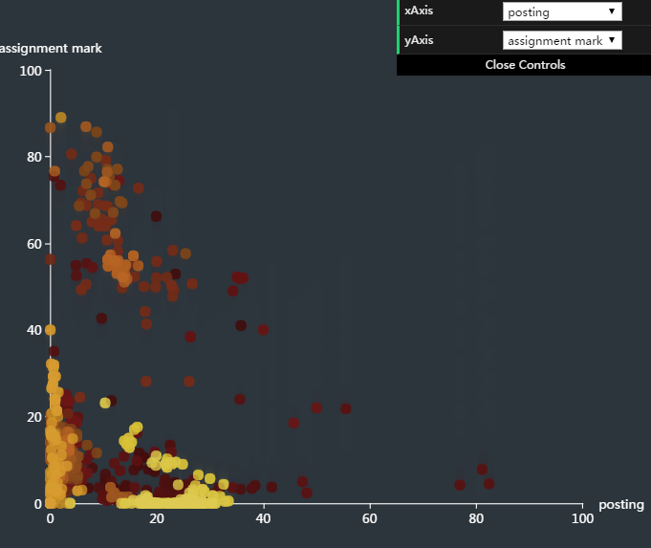
Figure 1: Relationship between posting and assignment mark

(3) If students cannot see the assignment mark immediately, they will keeping looking at forum discussion for insights. In this case, can you show me the students' posting behavior and assignment behavior on the same graph on the same time axis? Figure 1 shows students' posting, submission in same graph. Figure 2 shows students' posting, downloading and submission in same graph. Which figure do you think is easier for you to read?
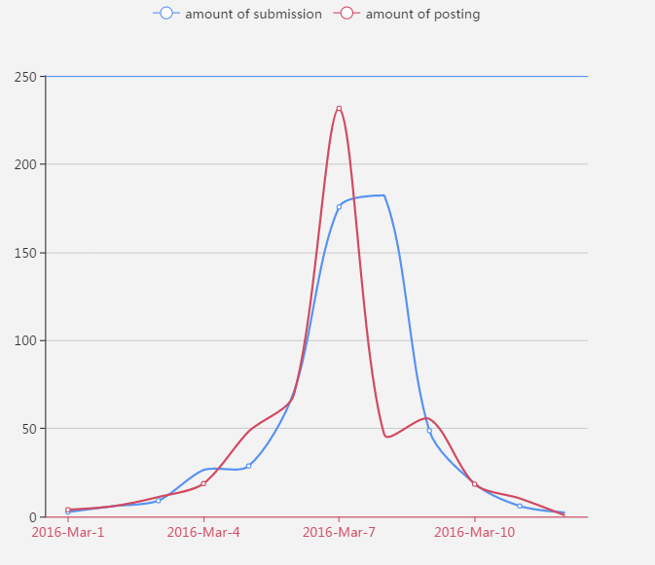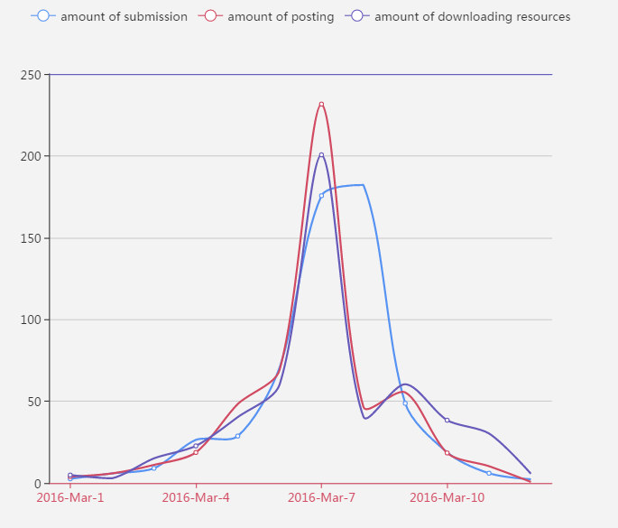
Figure 2: Posting and submission in same graph Figure 3: Posting, downloading and submission in same graph

(4) How does somebody perform in all the assignments of a course? What's the submission pattern of each assignment like?
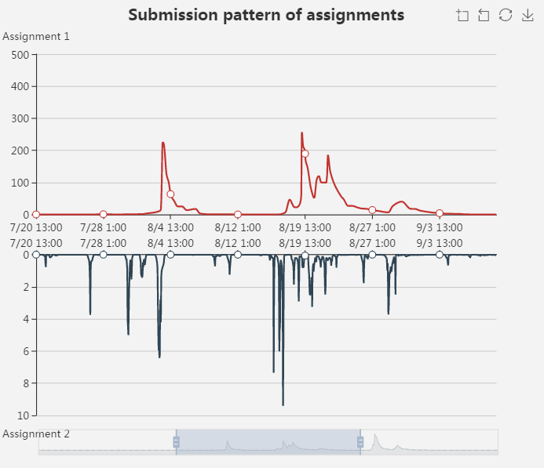
Figure 4: Submission pattern of different assignments

(5) If we have an average mark for a particular assignment, what do we need to display?
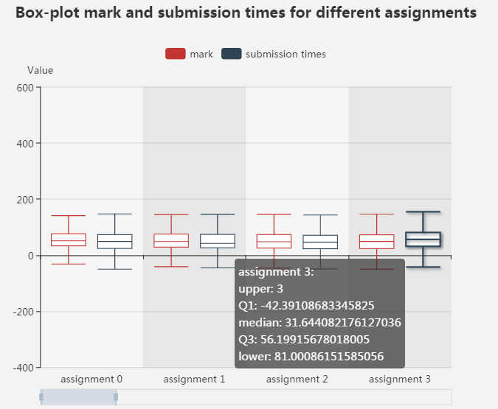
Figure 5: Box-plot mark and submission times for different assignments

(6) If a student always submits assignments early and submits one assignment late, what's the reason behind that?

(7) For group assignment, can you bring out submission patterns and look for a certain group and work out how many somebody has contributed?

(8) Are people who initiate forum threads likely to get better grades?

(9) From the start time of an assignment, one group starts working within a week, another group starts working within a month, the third group starts in the last week. Are they significant different groups from each other in statistical terms?

Please provide the questions you want our application to answer and provide your suggestions and preference of the graphical representation. Your ideas will be taken seriously and will have a chance to appear in our application.

